Stakeholders that have left the organisation need to be removed ASAP from Curtis Fitch.
- Locate a contract with the stakeholder on
- Click on the stakeholder’s name
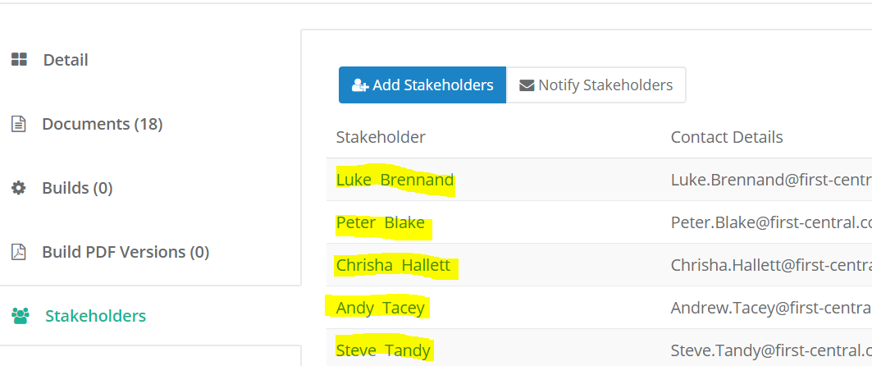
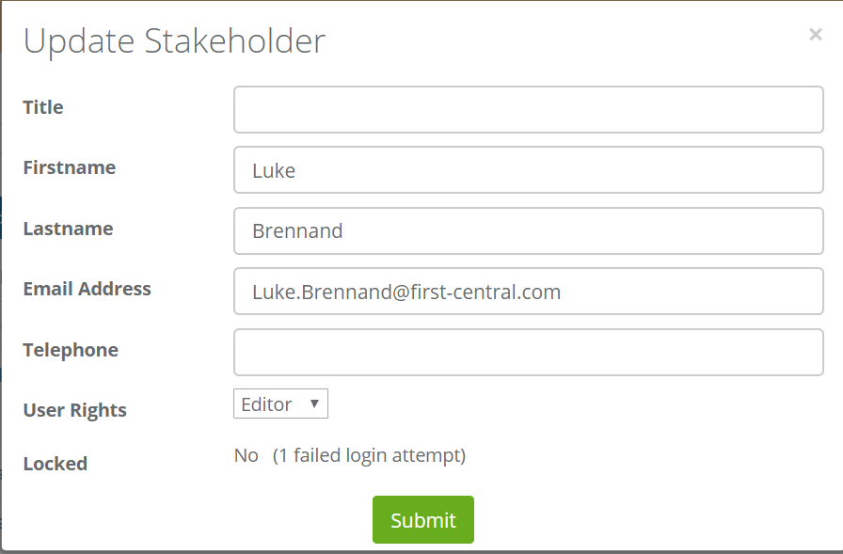
- Change the First and Last name to Do Not Use (continue numbering as per others)
- Change the email address to donotuse**@first-central.com (**fill in numbers) this will change it across ALL those contracts the stakeholder is assigned to

When you get a new stakeholder to add on those same contracts just go into it again and put their details in and they will be assigned to all of those contracts.

