Please note that you should not be editing the contract, this function is only for Procurement. If you do make any by mistake please make us aware ASAP.

- As detailed in the Adding Supplier Documentation Guide, when you click on the Contract title it will direct you to the below;
- Title is what Procurement have indexed the contract as
- Contract Template is MSA, T&C’s, License Agreement etc
- Assigned to is the member in Procurement managing the contract
Example below
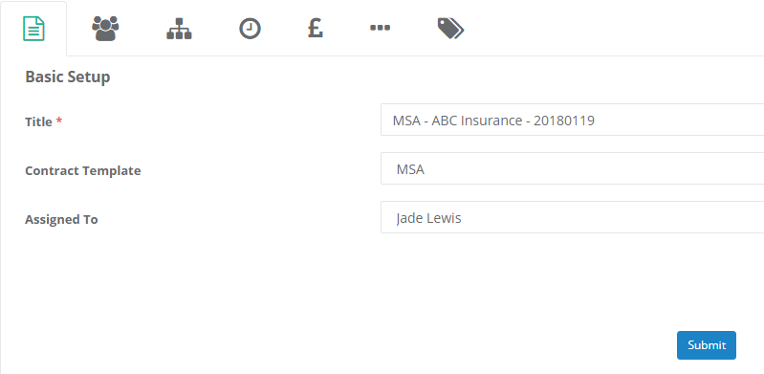
- The next tab is for Company/Contact info. 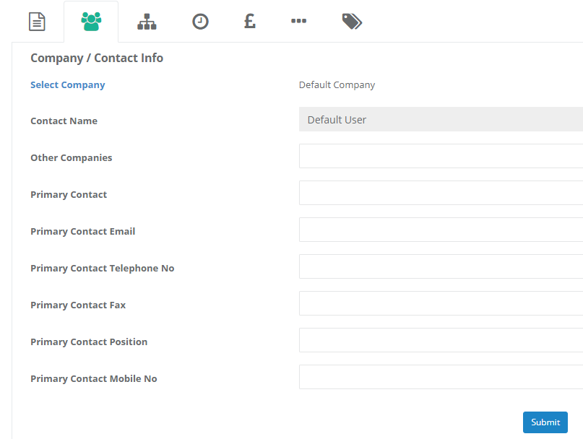
*Please make us aware of any contacts you have for your suppliers*

- Next is the Organisation tab.
- Contract type duplicates MSA, T&Cs, License Agreement etc
- Contract status is Live or Expired
- Contract category codes is to determine what it is that supplier is doing for us i.e. Hire Car, Cleaning, Telephony etc
- Contract assigned number we aren’t using
- Make Private again we aren’t using
- Contract workflow is for the workflow behind the scenes so we always select Yes
- Legal entity; FCIM, FCG, SICL, FCS UK, FCS GSY
- Budget holder as this could be a different department to the Business Area the Supplier is for
- Business Area so we know what area of the Business the Supplier is for, also helps distinguish which member of Procurement is managing the contract
- Goods and Service, where we select what the commodity is
- Associated Project is where we can detail what project (if there was one) the contract was in relation to

**Screen shot below**
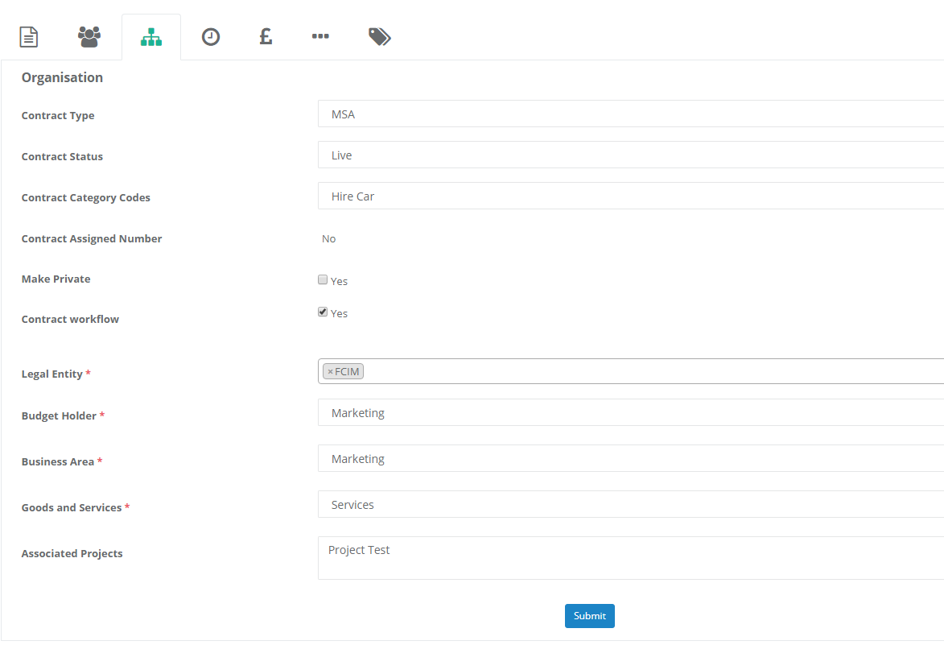

- Timings is where all of the dates relating to the contract are detailed, no need to explain further as this is self-explanatory

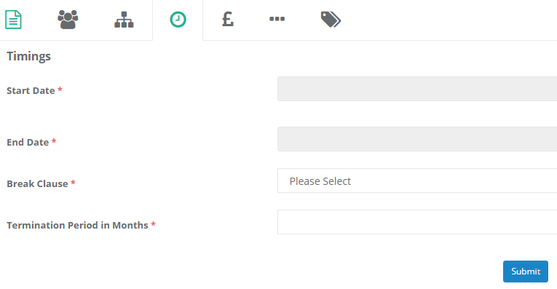

- Commercial/Financials – these are details about the contract we need to know from a budget perspective and also so we know in Procurement what the Business exposure is in relation to our spend and Suppliers. As you can see from below, commitment in contracts can be either spend or volume, this information is very important to the Procurement team.
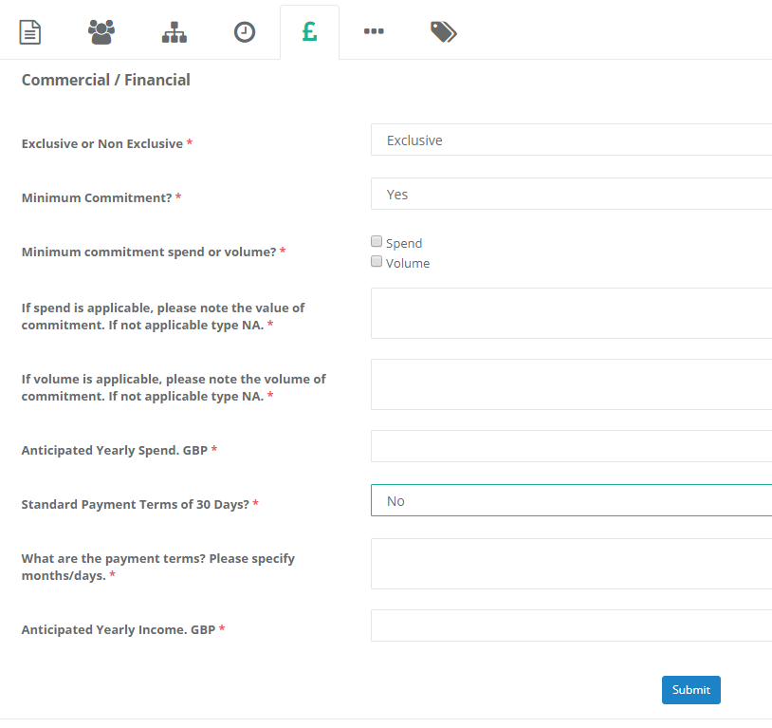

- The final tab ‘Other’ is where we state if there is any reference to other written documents.
It is also where we will document any additional comments about the contract we feel is important.
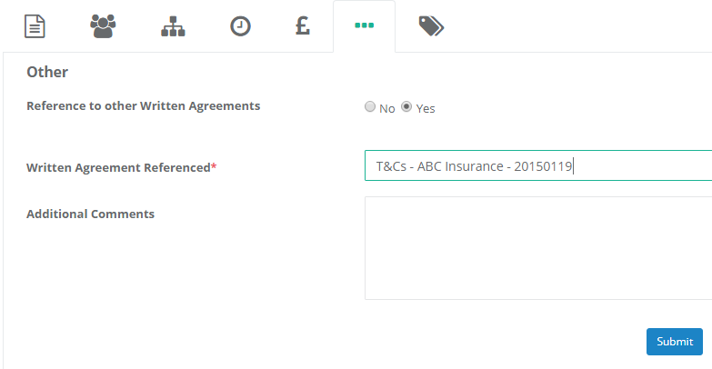

- On the left-hand side of the contract you will have the following tabs:
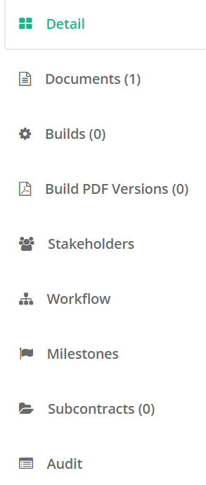
In the stakeholder’s tab you will see everyone we have given access to within the Business, if you need others added please make Procurement aware.
In the Milestones tab is where we have created any reminders for the contract (if necessary), for instance to renew, terminate or re-negotiate.

If you would like to go through this in more detail please contact Procurement@First-Central.com

