- When you log in you will land on your ‘Home’ page (as detailed in the screenshot below).
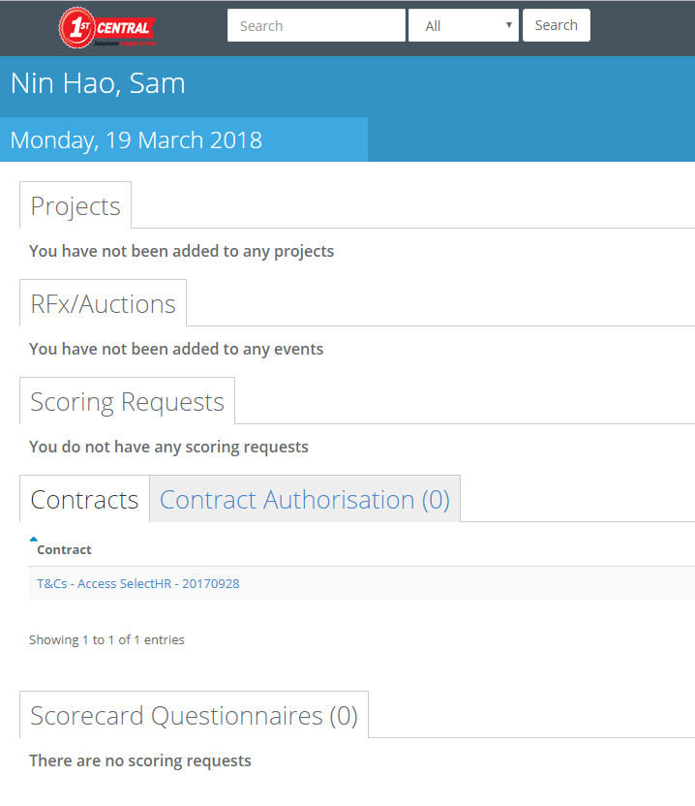
2. Under the Contracts tab is where you will find all of the contracts we have assigned to you. The contract is also where you will save all relevant Supplier documentation following any of your reviews with them, such as; Operational Performance Review and Strategic Review and so on.

The documentation should be added to the dominant contract, for example;
1st – MSA
2nd – T&Cs
3rd – License Agreement
4th – Framework Agreement
If there is no MSA you add to the T&Cs, if no T&Cs you add to the License Agreement and so on. There should not be an Addendum or a Novation without one of the above, however if there is one that you come across please make us aware.

3. Once you click on the relevant contract you are adding documentation to it will direct you to the main detail of the contract.
Example below
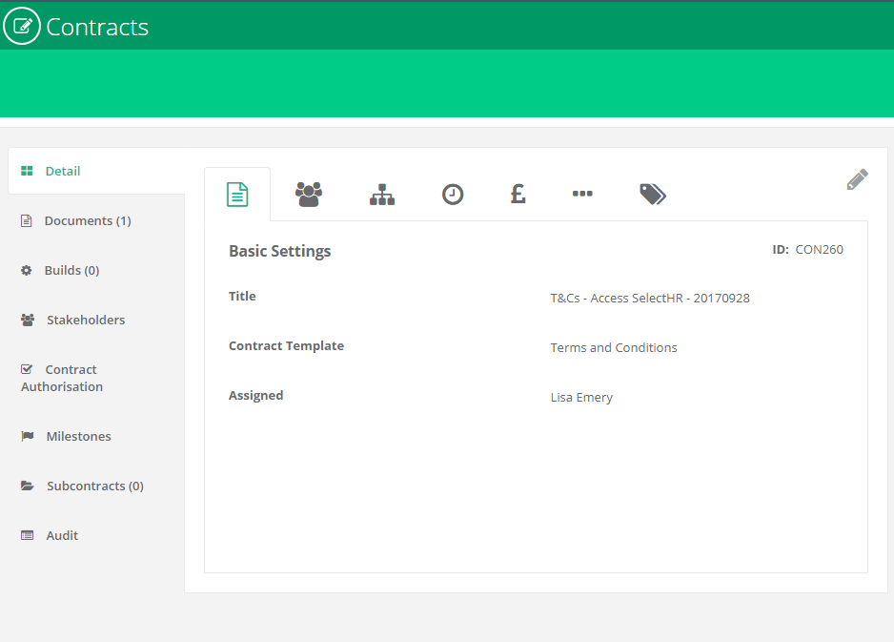
*Please refer to the Guide Contracts – Stakeholders for further information detailing the different sections of the contract*

The documents tab (as highlighted in Yellow) on the left hand side of the contract is where you will be uploading your Supplier Documentation.
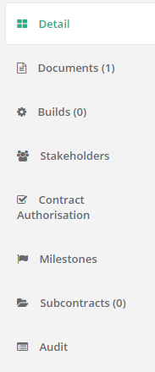

4. You will find the PDF Contract uploaded here which you MUST leave as it is.
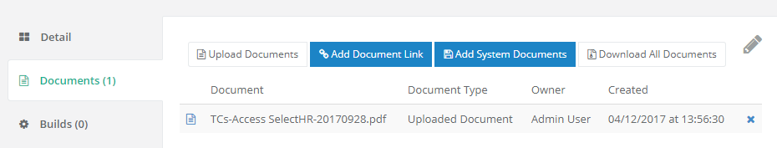

Important information
Please ensure that the document you are uploading is indexed appropriately, for example; Document type – Supplier name – Date // Strategic Review – Access Select HR – 20180319
Templates for Supplier documentation can be located here

To upload the document, click on ‘Upload Documents’


It will pop up this box;
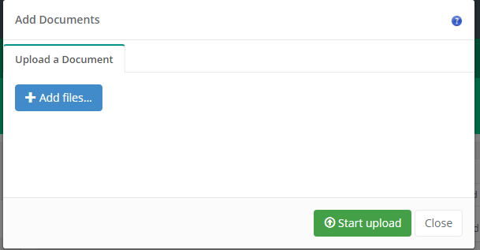

Click on ‘+ Add Files’ and search for the document you are uploading.
The document you are uploading will then appear in the box;
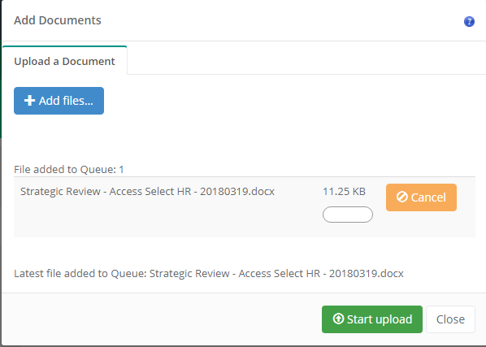
Next step is to click on ‘Start Upload’, once you have uploaded the document it will show you the below.
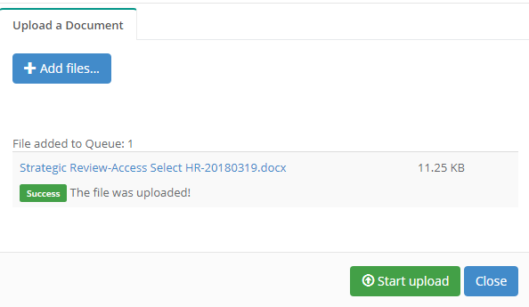
You can now just click on ‘Close’ and it is all done for you and will appear in the documents tab.
If you have any questions about this or require assistance please email Procurement@First-Central.com

