- When you log in you will land on the ‘Home’ page, go the hamburger icon  which is located next to the search function. When you click onto it the following modules will appear and you need to select Companies +
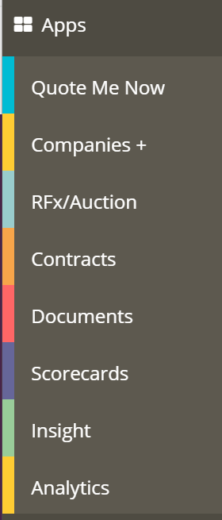

- When you land on the Companies + home page you need to click on the Create a New Company on the right hand side 

- All relevant information needs to be filled in as per detailed below is required the other cells can be ignored;
- Company Name
- Full address
- Telephone
- Website
- Approval Status
- Company Registration Number
- VAT number
- Supplier Relationship Type (as detailed on the risk assessment)
- CLICK SUBMIT

- Once you click Submit the following subsections will appear on the right hand side

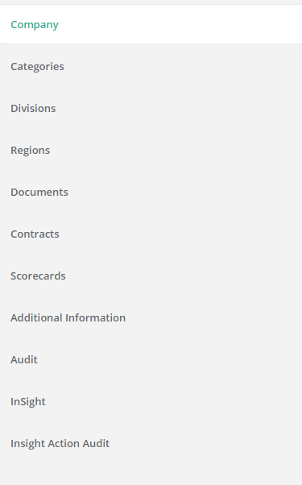

- Click back into the company tab and edit to assign a user of the Procurement Team (you cannot assign a user without having selected a Workflow stage which is above where you would assign the user).

This means the following;
- If they are NOT being on boarded do not send the reset password email and the supplier will not be able to log onto the system. This means we can put them into the workflow as a workaround for assigning a user to the company/supplier.
- However, if they are being on-boarded then send a password reset email and please follow the process as outlined in On-Boarding a Supplier

- Click on Additional Information and please complete the following;
- Credit check (if one has been done tick yes)
- Date of the credit check to be entered
- Approved to work with (if we are adding them then they should be so tick yes)
- Approved date (would be the date you are adding them to the system)
- Approved by (enter your name)
- Risk (mirror the risk assessment spreadsheet)
- CLICK SAVE

- When you are in the company information you will have this bar
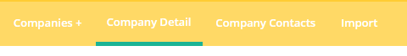
Click on Company contacts and add all relevant Company contacts and finally submit

This section is very important, if you do not add a contact you cannot add a contract. If you do not have a contact then please add a default one eg tbc@gmail.com

To send a password reset email, go back into the company contact details and click on the contacts name, this box will appear:

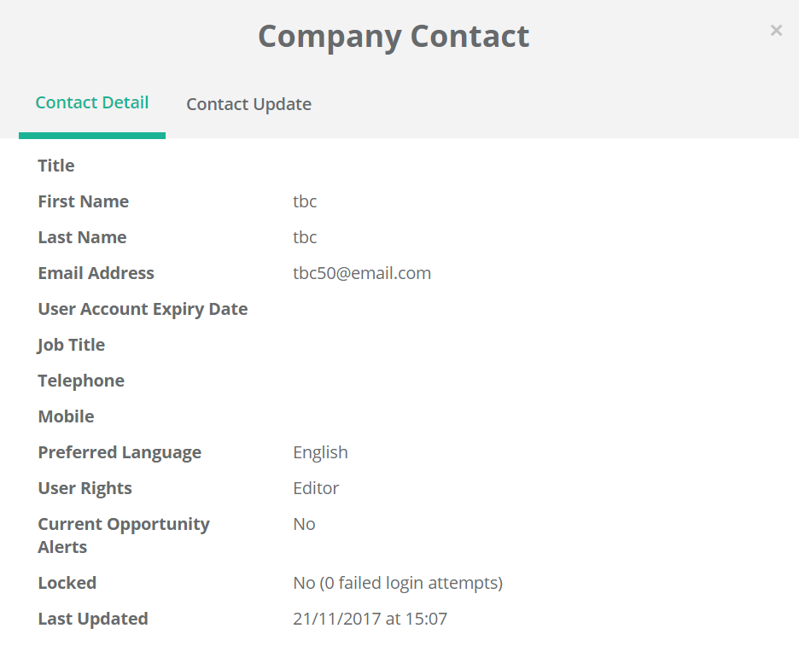
Go to ‘Contact Update’ and select send password reset email.
