- When you log in you will land on the ‘Home’ page, go the hamburger icon  which is located next to the search function. When you click onto it the following modules will appear and you need to select Contracts
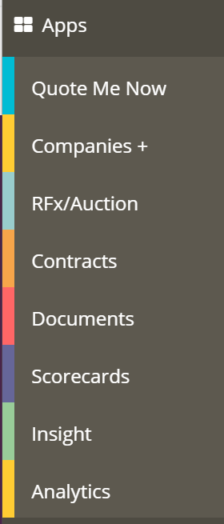

- When you land on the Contracts home page you need to click on the Create a New Contract on the right hand side 

- The first page it directs you to is called Basic set up and you will need to complete the following;
- Title – indexed appropriately
- Contract Template – selected from drop down menu
- Assigned to – who in the new is managing that contract
Example below
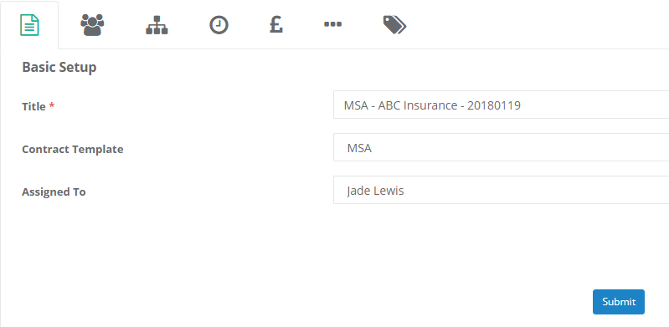

- The next tab is for Company/Contact info. You need to clock on the ‘Select Company’ which is highlighted blue, this MUST be selected to link the contract to the Companies+ module.

You also need to ensure that you enter any contact info relevant for this section.
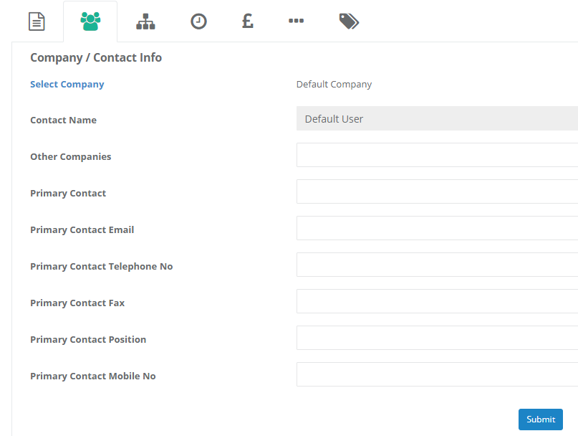

- Next is the Organisation tab, you will see that it prompts you to enter information and some of which are mandatory. All of this information is vital as we will be reporting on it.

**Screen shot below**
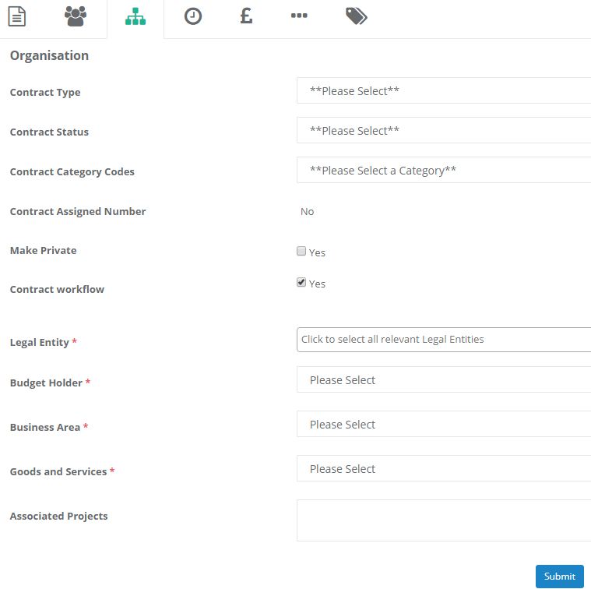

- Timings tab is self-explanatory, please fill out as appropriate
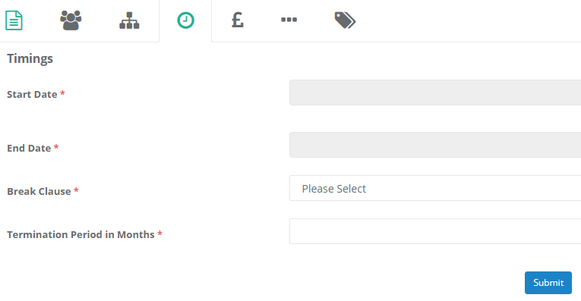

- Commercial/Financials again please fill out as appropriate. Anticipate yearly spend can either be an estimate based on what we know we already spend with them or what we will be spending with them. If there is no income please enter NA.
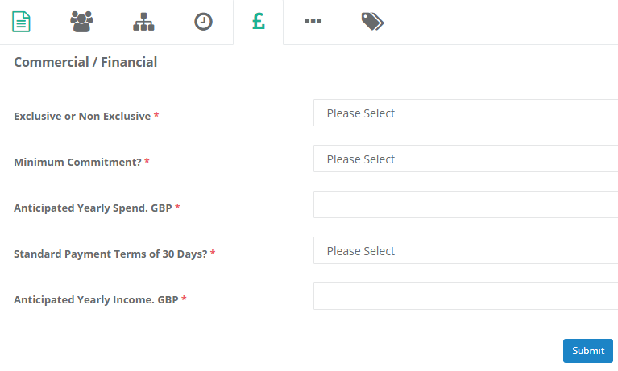
- The final tab ‘Other’ is where you state if there is any reference to other written documents. If you select yes then please paste the title of the document in the below, for example:
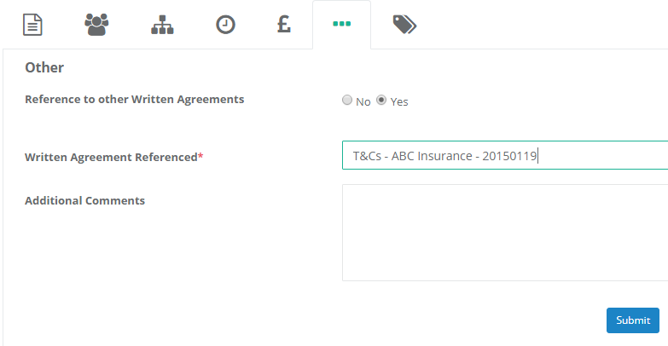

Once you have completed all tabs you can click SUBMIT. The system will not allow you to submit until all tab are completed.

- Once you have selected submit you will then be able to upload a document on the right hand side;
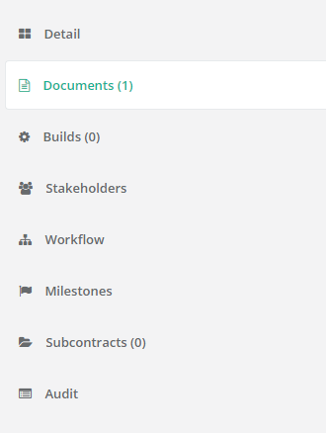

- Click on the Upload document and follow the process to browse for the document you require (which will be indexed the same as the title of the contract)
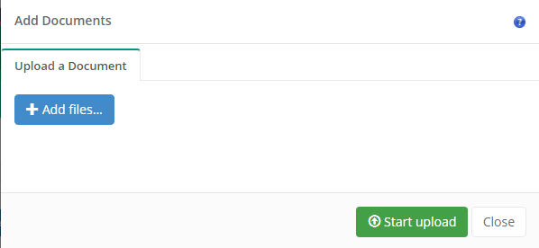

- Once completed and uploaded it will look like this;
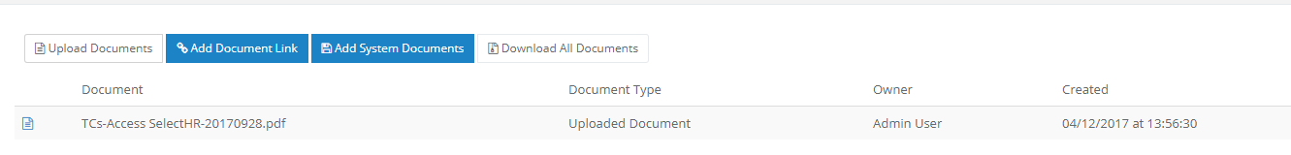

Other key information
If the contract you are creating is for Online Terms and Conditions please enter the link to the website on the other tab where it asks for additional comments;
