- On the left-hand side of the Contract (after you have created it) you will see the following tabs, click on Stakeholders:

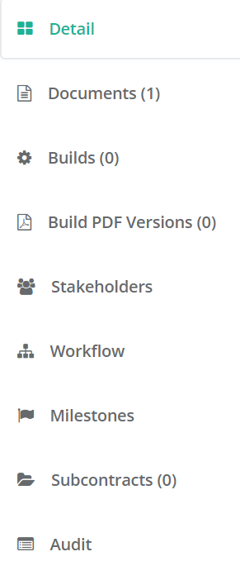

- This will give you the option to add stakeholders  which you can do individually or by adding the emails addresses:
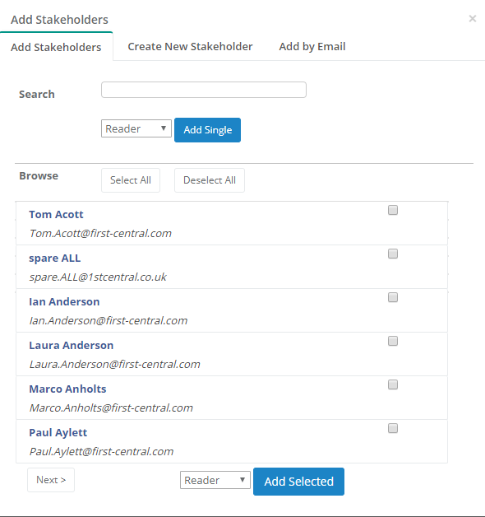

Please ensure you add the correct stakeholders as per the list located here
ALL stakeholders must also be down as editors to give them access to upload supplier documentation.

- Next you need to add your Milestone (if necessary) click on  which will bring up the below:
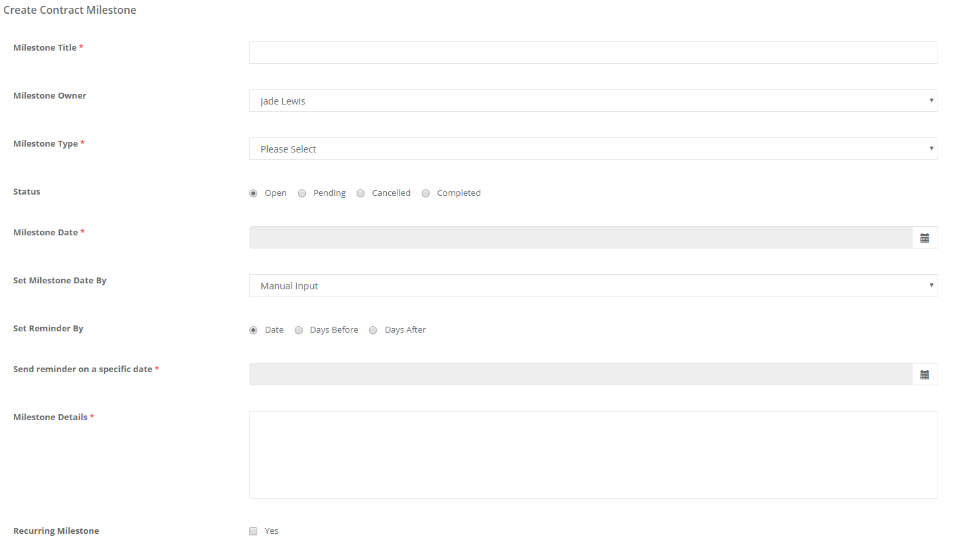

The title should mirror the milestone type i.e. Contract Review, Operational Performance Review, Strategic Review, Supplier performance Audit. Enter all other information is appropriate.

You can then add Recipients:

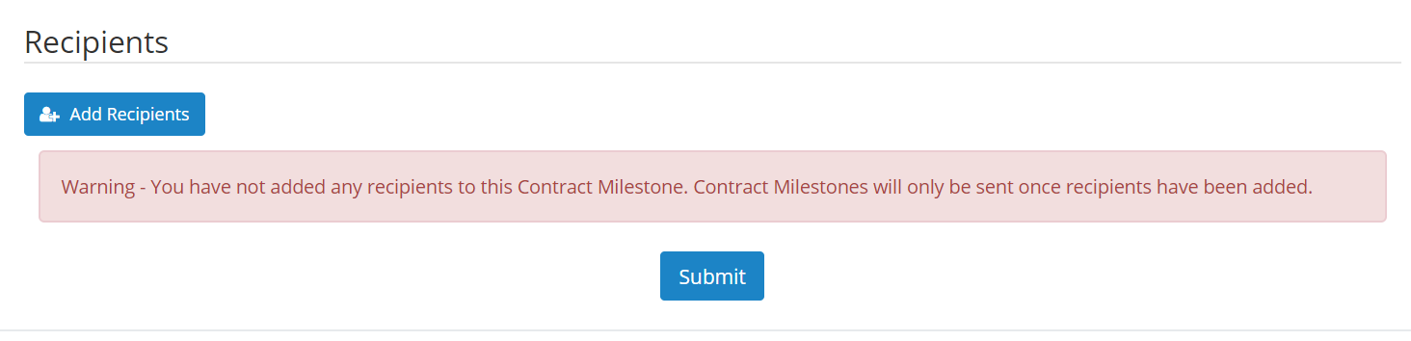
Finally submit.

